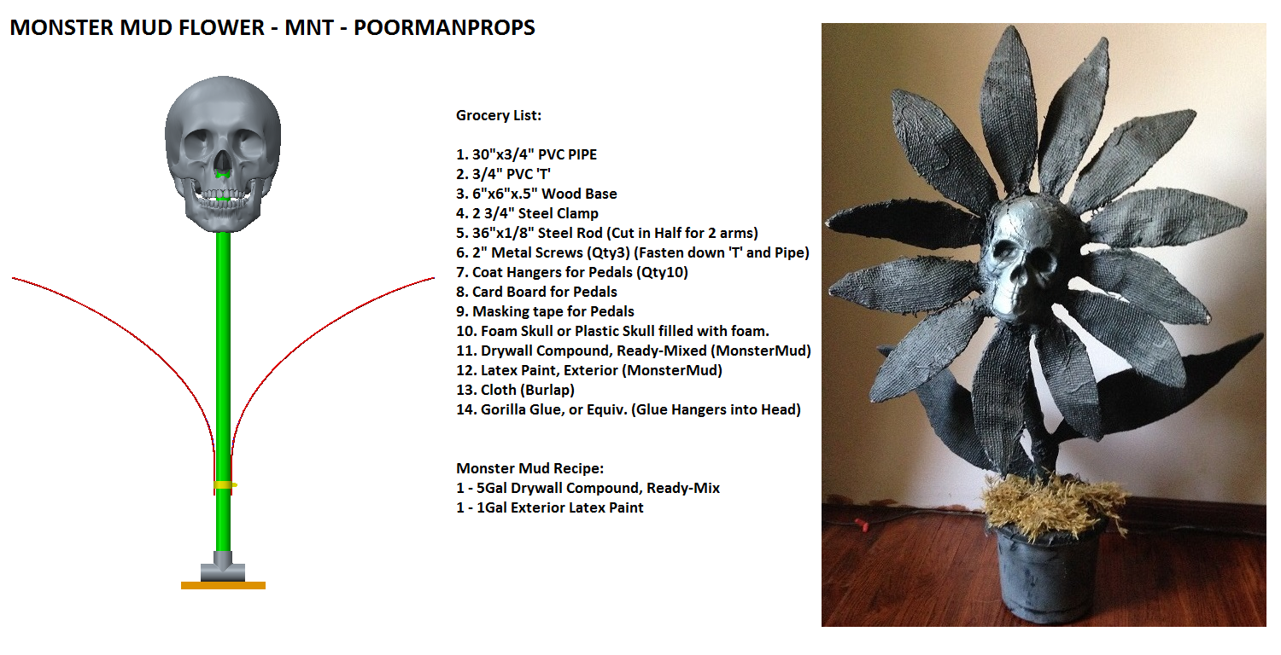

Monster Mud Flower Instructions

- Assemble PVC ‘T’ into wood base, using a couple screws.
- Assemble 30”PVC pipe into ‘T’, use screw to secure it.
- Cut hole into bottom of head, for the 30”PVC pipe, at the angle you want head to be at.
- Place head onto PVC pipe to check position.
- Cut 36”x1/8” steel rod into half. These will represent large leaves.
- About 5-6” above ‘T’ place steel rods and use steel clamp to lock into place. This may vary due to planter size you will eventually use.
- Bend the rods to the angle you want the large leaves to be at. Hold end of rods at pipe while bending, so, you don’t possibly break PVC.
- Cut coat hangers to roughly 12-14” in length. These will represent leaves on head.
- Cut out leaf shape out of cardboard for head and large leaves. You need only cut out for one side of leaf. Eventually the cloth will cover both sides. The cardboard is there for support until cloth dries.
- Using masking tape, attach cardboard leaves to steel rods.
- Stick coat hangers into head and equal spacing. Gorilla Glue if you wish.
- Using masking tape, attach cardboard leaves to coat hangers.
- Place head onto pipe if you took it off to attach leaves.
- Cut cloth into smaller sized sections and use mud to cover entire thing. Rule of thumb is thicker at base of leaves then the tips.

